**Spelling List:**

(short a)

man can

nap tap

cat hat

not does

|  |  |
| --- | --- |
| **Monday** | - **PLEASE NOTE: YOUR CHILD’S READING BOOK WILL COME HOME EVERY NIGHT, SO YOU ARE READY INCASE OF AN ABSENCE ETC…PLEASE BE SURE TO RETURN THE BOOK TO SCHOOL EACH DAY**  - Complete ‘Pop Words’ for Monday – have your child read the words each night and record the time – keep at home. (Flashcards are another option to practice HFW throughout the week)  - Math fact hw sheet sent home today – complete math facts for Monday – keep at home  - Read “Jack Can” (use little red reading book or Wonders online – use your login information)  - Practice spelling words  - Read through Weekly Word Recognition Practice sheet – keep at home and use all week long to review |
| **Tuesday** | - Reread “Jack Can” (use little red reading book or Wonders online – use your login information) – **test tomorrow**  - Complete ‘Pop Words’ for Tuesday – have your child read the words each night and record the time – keep at home.  - Complete math facts for Tuesday – keep at home  - Write your spelling words 3x’s each on sheet provided (both sides) – return to school |
| **Wednesday** | - Read “Nat and Sam” (use little red reading book or Wonders online – use your login information)  - Complete ‘Pop Words’ for Wednesday – have your child read the words each night and record the time – keep at home. **Tests tomorrow & Friday**  - Complete math facts for Wednesday – keep at home  **-** Practice spelling words – **test Friday** |
| **Thursday** | - Complete ‘Pop Words’ for Thursday – have your child read the words each night and record the time – keep at home. **Test tomorrow**  - Read “Rules at School” (use big red reading book or Wonders online – use your login information)  - Complete math facts for Thursday – keep at home  **-** Practice spelling words – **test tomorrow** |
| **Extras** | - Remember to return your child’s reading book(s) back and forth to school each day  - Practice monthly nonsense words a few times a week  - Optional Topic 1 Math hw handout- test this week  - Review math work mats / complete “Home Activity” or log onto Pearson Realize website each night to review skill  - Review, sign and return on Monday: your child’s behavior paper (*will be sent home most weeks / occasionally*)  - Don’t forget your Green B.E.E. Take Home Folder and 1 nut free snack with a label every day |

|  |  |
| --- | --- |
| **Monday** | - **PLEASE NOTE: YOUR CHILD’S READING BOOK WILL COME HOME EVERY NIGHT, SO YOU ARE READY INCASE OF AN ABSENCE ETC…PLEASE BE SURE TO RETURN THE BOOK TO SCHOOL EACH DAY**  - Complete ‘Pop Words’ for Monday – have your child read the words each night and record the time – keep at home. (Flashcards are another option to practice HFW throughout the week)  - Math fact hw sheet sent home today – complete math facts for Monday – keep at home  - Read “Jack Can” (use little red reading book or Wonders online – use your login information)  - Practice spelling words  - Read through Weekly Word Recognition Practice sheet – keep at home and use all week long to review |
| **Tuesday** | - Reread “Jack Can” (use little red reading book or Wonders online – use your login information) – **test tomorrow**  - Complete ‘Pop Words’ for Tuesday – have your child read the words each night and record the time – keep at home.  - Complete math facts for Tuesday – keep at home  - Write your spelling words 3x’s each on sheet provided (both sides) – return to school |
| **Wednesday** | - Read “Nat and Sam” (use little red reading book or Wonders online – use your login information)  - Complete ‘Pop Words’ for Wednesday – have your child read the words each night and record the time – keep at home. **Tests tomorrow & Friday**  - Complete math facts for Wednesday – keep at home  **-** Practice spelling words – **test Friday** |
| **Thursday** | - Complete ‘Pop Words’ for Thursday – have your child read the words each night and record the time – keep at home. **Test tomorrow**  - Read “Rules at School” (use big red reading book or Wonders online – use your login information)  - Complete math facts for Thursday – keep at home  **-** Practice spelling words – **test tomorrow** |
| **Extras** | - Remember to return your child’s reading book(s) back and forth to school each day  - Practice monthly nonsense words a few times a week  - Optional Topic 1 Math hw handout- test this week  - Review math work mats / complete “Home Activity” or log onto Pearson Realize website each night to review skill  - Review, sign and return on Monday: your child’s behavior paper (*will be sent home most weeks / occasionally*)  - Don’t forget your Green B.E.E. Take Home Folder and 1 nut free snack with a label every day |

**Reminders**

**PLEASE NOTE: YOUR CHILD’S READING BOOK WILL COME HOME EVERY NIGHT, SO YOU ARE READY INCASE OF AN ABSENSE ETC…PLEASE BE SURE TO RETURN THE BOOK(S) TO SCHOOL EACH DAY**

**Please help your child remember to return their books on library day so they are able to check our new ones**

**Scholastic Book Order Due: Wednesday, September 19th**

**Read-A-Thon Begins: Monday, September 24th**

**Red & White Day: Friday, September 29th**

**What We're Learning**

**Reading / Language Arts:**

- Essential Question: What do you do at your school?

- Comprehension Strategy: visualize

- Comprehension Skill: key details

- Writing Traits: ideas

- Grammar: sentences

- Structural Analysis: inflectional ending –s

- Mechanics: sentence capitalization

- Stories: Nat and Sam (Realistic Fiction), Rules at School (Nonfiction), Jack Can (Realistic Fiction)

**Math:**

We will finish and test Topic 1: Understanding Addition. We will use the words sum, plus, add, and equals in our creating of addition sentences. Please review the work mat with your child (you can also complete the home activity at the bottom of the page for extra practice) or log into Pearson Realize to supplement the lesson.

**Science /Social Studies:**

This week we will finish up our unit on families. We will then learn about germs.

Each week a calendar like this one will come home in the back of your child’s Green Take Home Folder. It will let you know what the suggested homework is for the week and upcoming special events. This calendar should remain in the back of your child’s folder for the whole week. The folder should come back and forth to school every day.

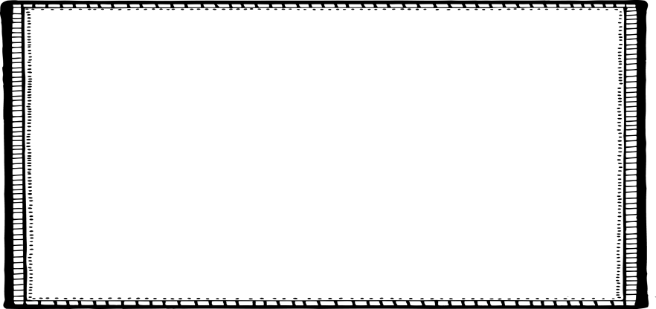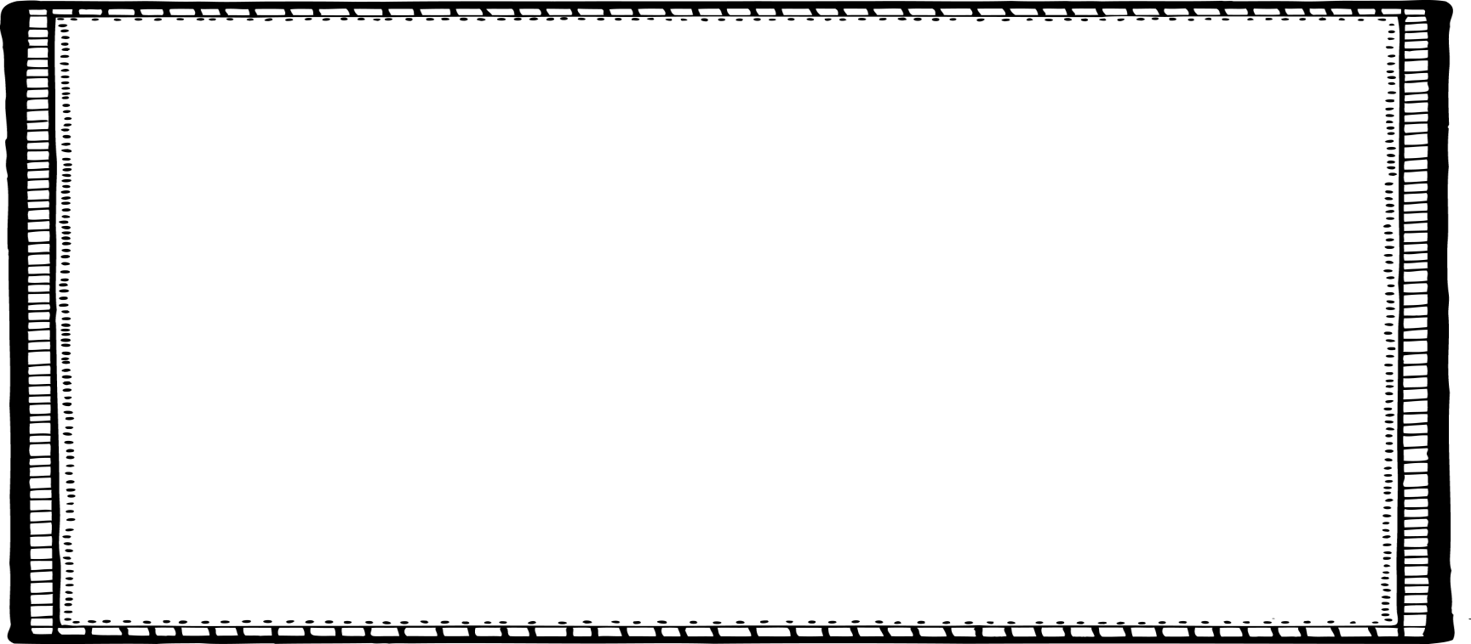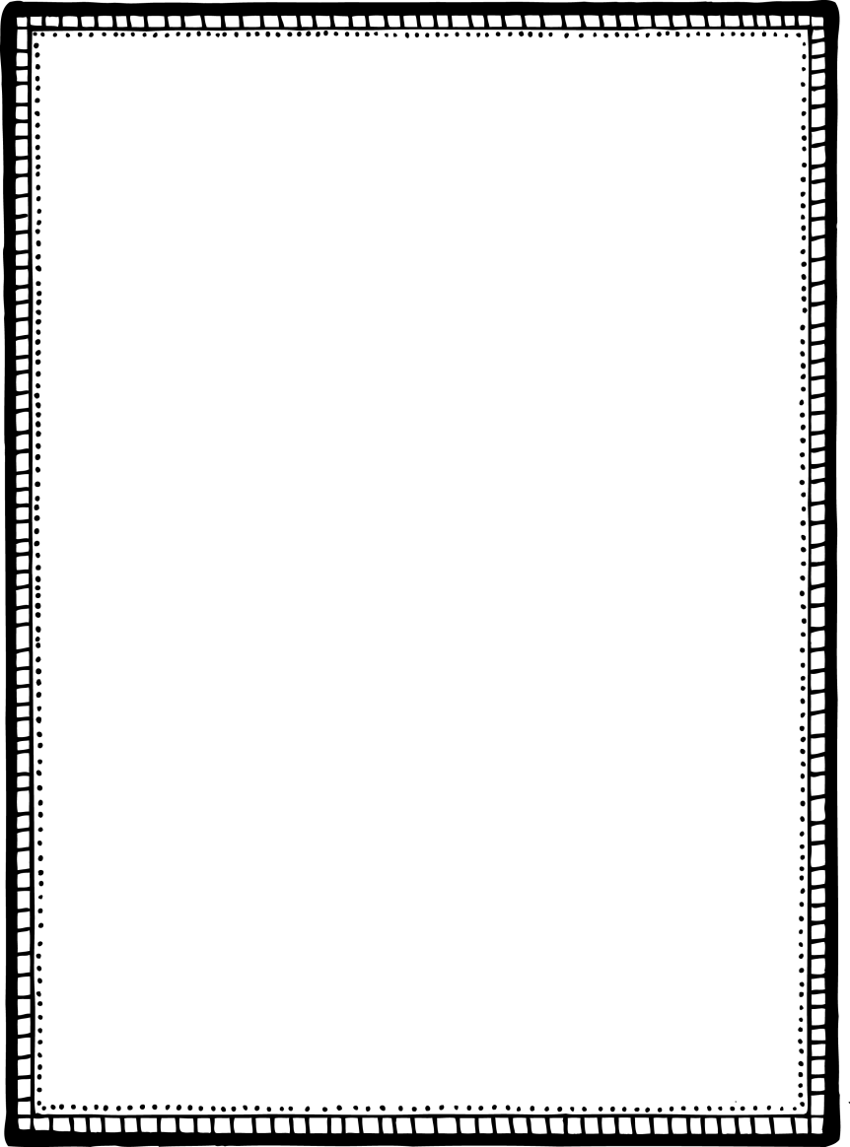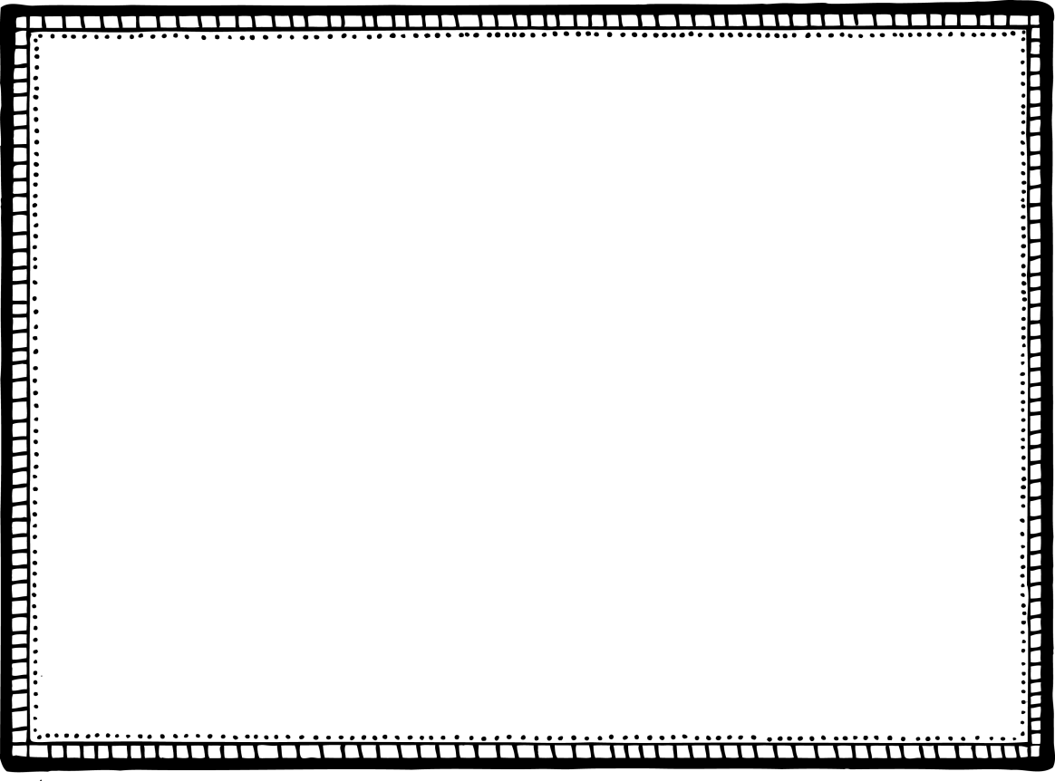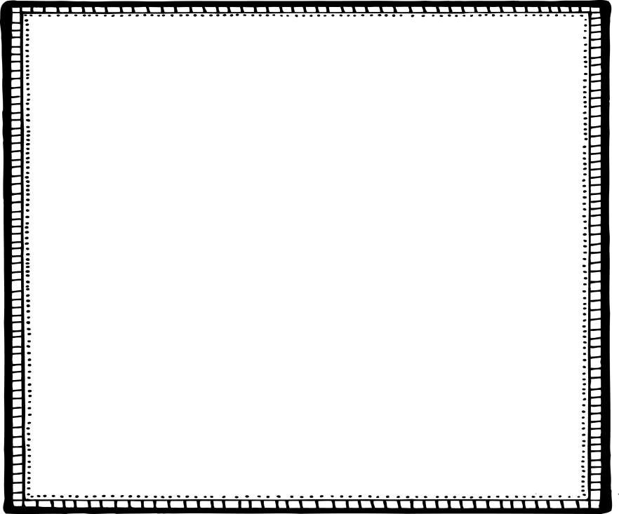

**High Frequency Words (HFW):**

does

not

school

what

**Oral Vocabulary**

*(students only need to be familiar with what the word means- will not be assessed on words)*

learn- to gain knowledge or a new skill

subjects- things you study at school

common- normal, ordinary, or easily found

object- a thing or an item

recognize- to remember something because you have seen it before

**Weekly**

**Newsletter**



Week of 9/10/18

August 30

