|  |  |
| --- | --- |
| **Monday** | No School |
| **Tuesday** | - Complete ‘Pop Words’ for Monday & Tuesday – have your child read the words each night and record the time – keep at home. Assessment upcoming.  - Begin to practice math facts to sums of 6 |
| **Wednesday** | - Complete ‘Pop Words’ for Wednesday – have your child read the words each night and record the time – keep at home  - Begin to practice math facts to sums of 6 |
| **Thursday** | - Complete family worksheet – return to school  - Complete ‘Pop Words’ for Thursday – have your child read the words each night and record the time – keep at home.  - Look for September Nonsense Words list coming home today – keep some place safe and practice all month long  - Begin to practice math facts to sums of 6 |
| **Extras** | - Practice monthly nonsense words a few times a week  - Name each short vowel sound (a, e, i, o, u)  - Review math work mats / complete “Home Activity” or log onto Pearson Realize website each night to review skill  - Review, sign and return on Monday: your child’s behavior paper (*will be sent home most weeks)* |

**Reminders**

**Please help your child remember to return their books on library day so they are able to check out new ones ☺**

**PLEASE REMEMBER TO RETURN YOUR GREEN BEE FOLDER TO SCHOOL EACH DAY AS WELL AS BRING IN ONE NUT FREE SNACK WITH A LABEL**

**Scholastic Book Order Due: Wednesday, September 19th**

**Read-A-Thon Begins: Monday, September 24th**

**Red & White Day: Friday, September 28th**

**Spelling List:**

Start Smart

Week 3

**What We're Learning**

**Reading / Language Arts:**

- Phonemic Awareness: Phoneme Isolation / Phoneme Blending

- Phonological Awareness: Rhyme

- Comprehension: Making connections

- Word Work: Kk, Cc, Gg, Ww, Xx, Vv, Qq, Jj, Yy, Zz, Short u

We are continuing to review our letter sounds, and sight words from kindergarten. Please practice these sounds and words so they know them quickly. These pre-reading skills are very important to learning to read. We will be testing letter sounds and sight words.

**Math:**

We will continue Topic 1: Understanding Addition. We will be using the words sum, plus, add, and equals in our creating of addition sentences. Please review the work mat with your child (you can also complete the home activity at the bottom of the page for extra practice) or log into Pearson Realize to supplement the lesson.

**Science /Social Studies:**

Great job on the bus and stranger safety rules. We will begin learning about families.

Each week a calendar like this one will come home in the back of your child’s Green Take Home Folder. It will let you know what the suggested homework is for the week and upcoming special events. This calendar should remain in the back of your child’s folder for the whole week. The folder should come back and forth to school every day.

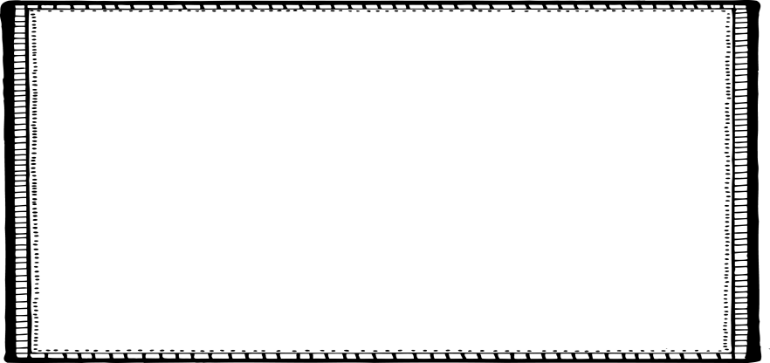

**High Frequency Words (HFW):**

are and

me have

she see

with said

for was

**Oral Vocabulary**

*(students only need to be familiar with what the word means- will not be assessed on words)*

**Weekly**

**Newsletter**

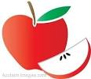

Week of 9/3/18

August 30

